Hello families, I am sure you will all agree that the first half term has gone so quickly. All the children have settled in very well and we are very pleased.

Autumn term 1

The children have been busy in the past weeks, and we hope you have enjoyed the children’s artwork they have bought home.

This term we have shared colouring pictures and books in club relating black history month. Over table 5 we celebrated Roald dahl’s birthday, our much-loved children’s author who transformed countless children into readers.

Children have been making sensory bottles, lava bottles and shakers. Mindfulness colouring has been enjoyed by many children during the afternoons

Reception have enjoyed our new selection of musical instruments and blowing bubbles whilst trying to catch them on paper.

Many children have joined our chess class promoting their critical thinking and creativity whilst learning a new game and having fun!!
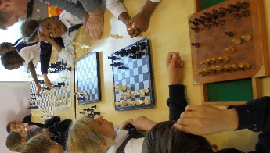

Menu

Please visit the clubs
website earlybloomers.co.uk
to see our updated menu.

Absence Notifications

When informing the club of your child’s absence please can you send a SMS message directly to the club phone on 07763297128

Breakfast placement availability

We have availability at breakfast club, Monday to Friday should you require this. If you know of any other families around school who may be interested, please do let them know

Lost property

This will be available for you on a Wednesday afternoon between the hours of 4:30 and 6pm outside main office

We wish you all an enjoyable half term

Thank you
Early Bloomers Staff

