Early Bloomers
Newsletter

5th June – 21st July
Hello again to all our Early Bloomers families, what a lovely summer term we have had at club.
The children have continued to join in the chess lessons on a Wednesday and improving weekly. The football table and table pool have stayed favourites whilst we have had to spend a little more time inside this term due to the wet weather.
Please see some of the exciting things children have been getting up to.
Highlights:
Table 1:
Over on Table 1 we have done loads of crafts and getting
messy this term, playing with jelly, and making paintings
out of bubbles. We have really enjoyed using the stamp set
with paint and making our own with sponges. The children
have enjoyed getting the cart mat out and having races also.
Table 2:
On table 2 we enjoyed having the tabletop air hockey
and seeing who can score the most. We designed medals
after sports day and made lots of lovely play dough that
we enjoyed rolling out and using the cutters.
Table 3:
Table 3 love to be creative and have made loads of
pom poms and bracelets this term. They have made chocolates.
out of playdough, decorated with glitter and sequins. We’ve
also made lovely thank you cards for our teachers.

Table 4:
Table 4 have had a busy term, they have made their own marble
run, which the children have continued to enjoy every day. Lots of
playdough and modelling clay has been used to make sushi shops and
doughnut shops. We put our thinking caps on and made boats and rafts
that we think could float, then tested them out in the water.
We added weights and created waves to see if our deigns could survive.

Table 5:
Table 5 love to get messy and enjoyed jelly play, making pyramids
and squashing them. Lots of junk modelling and painting.
This term we have been playing lots of cards and board games,
especially enjoying draughts and harry potter themed card games.

Contact details.
Kindly ensure your telephone numbers are up to date at the club so that we can contact you in an emergency. All details can be updated by sending in an email to admin or completing parts of the registration, which can be found on our website.
Fees
Fee’s structure has been updated for September 2023 and a copy has been attached.
Absences
Please continue to send absence notifications to our club phone 07763297128. All other communication should be sent by email.
Feedback
Early Bloomers have worked tirelessly around the year ensuring the wrap around care around your child’s school day is a happy and healthy experience. We would love to hear your views on how we have done this year and how we can improve next year, you will shortly receive a survey and we would be grateful if you could complete and return.
Goodbye!
We are saying goodbye to our year 6 children most of which have been with us for years and some since they were only 4 years old. We wish them all good luck at their secondary Schools.
Thank you!
I would like to take this opportunity to thank you all for your continued support and wish you the best summer holidays. We look forward to seeing you all in September 2023

Kind regards,
Early Bloomers Team

Which boat floats?
Creations !!
Binoculars in the making

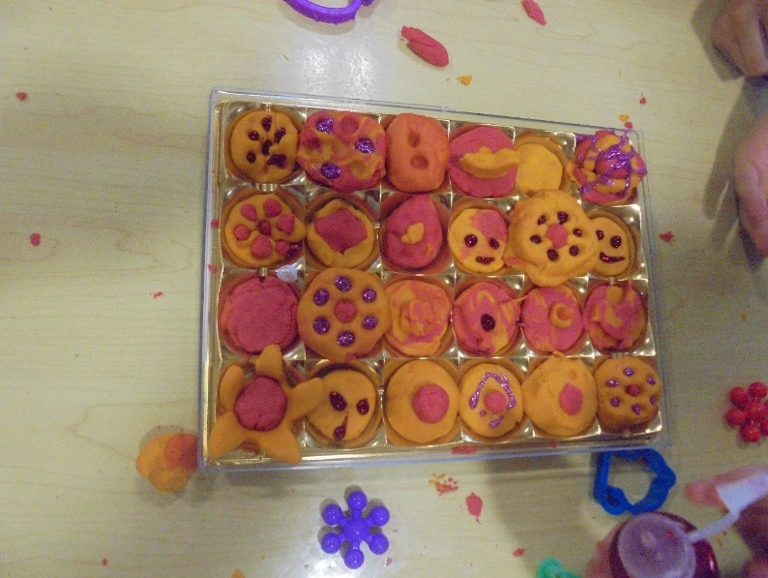
Chocolate playdough creations

Planet Friendly Team at EB

Getting competitive
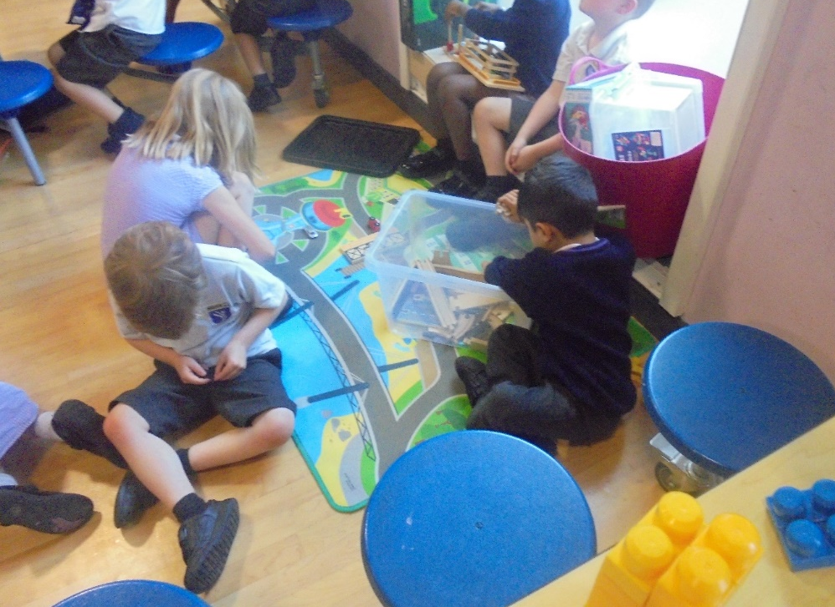
Imaginary play

