Hello again,
This term the children have been busy mainly with arts, crafts welcoming the new year 2023, celebrating the Chinese new year, creating animals from Origami, messy play, painting, playing instruments and much more! Our new football table has arrived and is available for the children each evening to book a game on there with a choice of 3 other friends and it’s been busy in that area! With the weather being a bit drier the children have been able to stay out for longer which was one of our top requests in our recent children’s survey.

Spring Term
It’s been a busy half term throughout the club, and we have shared some photos of the fun time spent over the weeks. Children have been tactical in creating their own puzzles, using lolly sticks, we’ve had some great designs. Over our early years table children have got stuck into heaps of messy fun including salt painting, minibeast hunting, printing, foam fun, mixing colours to make new colours and much more.

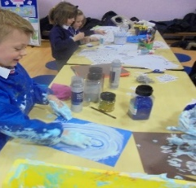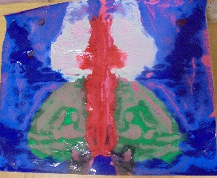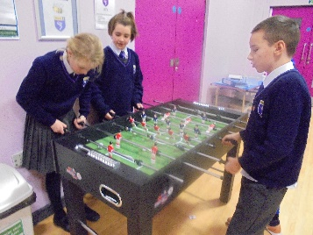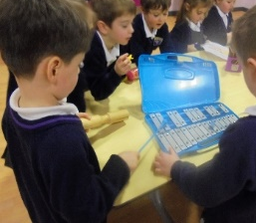
Absence Notifications
Please can we ask that absence notification messages are sent to the club phone on 07763297128, as these do still come in as email and we want to ensure we update registers in time for club.

Upcoming
After half term, children will be taking part in fundraising for red nose day. Please look out for further details!
Tuesday 21st February children will take part in making pancakes.

Chess update
Chess classes are going exceptionally well and we have more and more children wanting to join each week, please see Gerry’s recent feedback

“HI TAL
THE CHESS SESSIONS ARE GOING VERY WELL, WITH AS MANY AS 16 CHILDREN ATTENDING AT ONE TIME.
AS THE CHILDREN BECOME MORE CONFIDENT AT THE BOARD, I HAVE BEGUN TO STRETCH THEIR MINDS A BIT MORE. THEY NOW HAVE TO CALL OUT THE MOVE THEY ARE MAKING IN CHESS NOTATION AND SAY WHAT THE REASON IS FOR MAKING THAT MOVE. THIS ADDITIONAL DEMAND IS PROVING SURPRISINGLY POPULAR AND WILL HELP TO FORTIFY THEIR THOUGHT PROCESSES”.
Late collection
If you find you will be late collecting, you can avoid getting a late fee and pre book till 6:30 for an extra £10. Please allow a days’ notice

Fees that don’t reach us on time without an acceptable reason/ prior arrangement will incur administration charge

We hope you have an enjoyable half term.

